A machine learning algorithm to predict knee joint loading in real time
WANG Chao
Department of Electronic Engineering, City University of Hong Kong, China
ABSTRACT
Patient with pathogenesis of knee osteoarthritis (OA) will have a higher knee loading while walking. In clinical treatments, patients will be trained in order to reduce the knee loading. In gait analysis, knee adduction moment (KAM) is usually used to estimate the knee loading.
The traditional method to measure KAM requires an intricate and expensive equipment. The experiments are usually conducted in laboratory. And subjects need to wear many sensors, which is very inconvenient.
In this study, we want to simply use fewer wearable sensors in subjects’ ankle to predict the KAM values during walking. A machine learning model will be proposed to estimate the KAM values in real time.
Prepare an informative abstract of up to 300 words based on the complete paper. The abstract should provide a concise synthesis of the entire paper, including the purpose of the study, method, main findings, and interpretation of their significance. The abstract should not contain any equations, symbols and references. Furthermore, the abstract should be a self-contained statement that summarizes the entire paper. Note that the list of abstracts (not full papers) will be distributed in the conference together with the conference programme.
Keywords: Style, format, checklist, Microsoft Word, EASEC12.

INTRODUCTION
The recommended length of conference papers is 4 to 6 pages, and the maximum length is 8 pages (maximum) including references, figures, and tables. The maximum file size for the electronic version (Microsoft word file) of the paper is 10 Mbytes. The maximum number of pages can be increased to 10 for keynote papers. The number of pages is counted using papers with ISO A4 size with 2.5 cm top and bottom margins and 2.0 cm left and right margins.
To submit a conference paper to EASEC12, authors should try their best to typeset their paper following the style given in this template. All papers must be submitted electronically in Microsoft Word format through the conference website (http://www.bc.cityu.edu.hk/easec12).

GENERAL PAPER STYLE
Authors must use Times New Roman font throughout the paper with single line spacing and 6 pt above and below each paragraph. All text, except for the title, is in 12 pt. Authors can use the Normal style in this template for the text part of the conference paper.

Title
The paper title must be in BOLD 14 PT UPPERCASE. Leave 24 pt between the top margin and the paper title, and leave 12 pt between the paper title and the names of authors. The line spacing of the paper title is exactly 18 pt. Authors can use the Title style in this template.

Authors
The authors’ name is in single line spacing with 12 pt above and below. Authors can use the author style in this template. Please indicate the corresponding author and the presenter together with their email address at the footnote.

Affiliations
Try to fit the affiliation of an author in one line. Don’t leave any blank line between affiliations. The affiliation should be italic. Authors can use the affiliation style in this template.

Abstract
No section number is assigned to the abstract heading, which is in single line spacing with 12 pt above and 6 pt below. Authors can use the heading without number style in this template for the heading of the abstract.

Keywords
Select up to five keywords, which describe the contents of your paper. Leave 6 pt above and below the Keywords.

SECTION (MAJOR HEADING)
Authors can use the Heading 1 style in template for major headings. Major headings should be placed flush with the left margin, typed in BOLD CAPITALS and identified in Arabic numerals. Leave 12 pt and 6 pt above and below major headings, respectively.

Sub-section (Sub-heading)
Authors can use the Heading 2 style for the sub-headings. Sub-headings should be typed in bold upper and lower cases flush with the left margin with a second level of Arabic numerals. Leave 12 pt and 6 pt above and below the sub-headings, respectively.

Sub-sub-section (Sub-sub-heading)
Authors can use the Heading 3 style for the sub-sub-heading. Like the sub-headings, the sub-sub-headings should be typed in bold upper and lower case flush with the left margin, but should be identified with a third level of Arabic numerals. Leave 12 pt and 6 pt above and below sub-sub-headings, respectively. Try to avoid using sub-sub-sub or higher subsections.

EQUATIONS
Including symbols and equations in the text, the variable name and style must be consistent with those in the equations. In equation (1), I used the symbols φ, c and t. In equation (2), ρ and ω are employed. Equations should be indented at the left margin and numbered at the right margin. Leave 6 pt above and below a equation. For examples
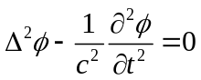 (1)
Consider also the following equation
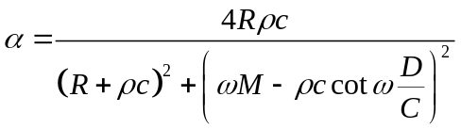 (2)
Equations (1) and (2) are examples to show the required style of equations. Define all symbols the first time they are used. The equation style in this template can be used.

TABLES
Table 1 shows a typical example of a table. Authors should us 10pt Times New Roman font in tables with line spacing equals to 12pt. A caption must be given above the corresponding table. Tables should be centered and put at appropriate places in the paper. The table style can be adopted.
Table 1: An example of table style
Case | x | y | B | J_{min}
I | 4 | 1.0 | (1.0, 0.0) | 0.000201
 | 4 | 1.0 | (0.0, 1.0) | 0.000357
 | 4 | 5.0 | (1.0, 0.0) | 0.001309
 | 4 | 5.0 | (0.0, 1.0) | 0.007228
II | 16 | 1.0 | (1.0, 0.0) | 0.003555
 | 16 | 1.0 | (0.0, 1.0) | 0.002169
 | 16 | 5.0 | (1.0, 0.0) | 0.009673
 | 16 | 5.0 | (0.0, 1.0) | 0.007291
The caption of a table must be centered and typed in bold. The Caption style in the template can be used.

FIGURES
Please refer to Figure 1 for a typical example of a figure. A caption must be given below the corresponding figure. Figures should be centered and put at appropriate places in the paper. Leave 6 pt above and below the figure. The figure style can be used.
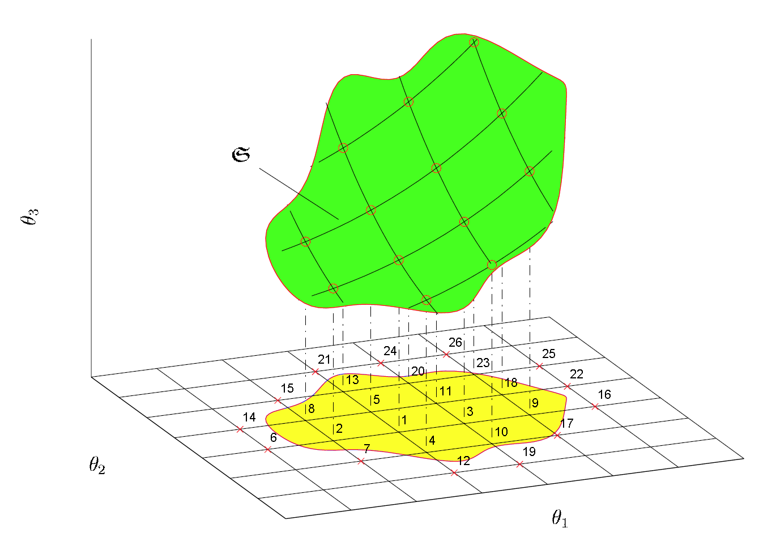
Figure 1: An example of figure style.
The figure caption must be centered and typed in bold. The Caption style in this template can be used.

CITATIONS AND REFERENCES
References should be cited in the text using the “author’s surname year” format in parenthesis. For reference with only one author, it can be cited as (Beck 1989). In case of two authors, the citation should be (Lee and Ng 1998). If there are more than two authors, state the first author only and add “et al.” in the citation as (Kinsler et al. 2000). To cite several references together, semicolon should be used between references as (Beck 1989; Kinsler et al. 2000; Lam 1999; Lee and Ng 1998; Lam et al. 1998; Lam 1997). The references should be cited in tables or figures and legends in the same manner as in the text.
References should be listed in alphabetical order in the list of references without any index number. References should be started with the last name of the first author and followed by the initial. If there are two authors, put “and” between two author names. If there are more than two authors, use comma to separate author names and put “, and” before the last author name. Please refer to the REFERENCES for the sample format of references. Reference (Lee and Ng 1998) is a journal paper, reference (Beck 1989) is a conference paper, reference (Kinsler et al. 2000) is a book, reference (Lam 1997) is a technical report, and reference (Lam 1999) is a PhD thesis. The references should be typed with font size 10 pt, line spacing 12 pt and 1 cm hanging indentation.

CONCLUSIONS
Do not simply repeat the results or discussions, but provide some overall comments on the findings and their applicability in other settings or applications. The discussion of implications should tell the reader what the importance of the work is for others.

ACKNOWLEDGMENTS
A short section may acknowledge assistance and sources of financial support.
REFERENCES
Beck JL (1989). Statistical system identification of structures. Proceedings Fifth International Conference on Structural Safety and Reliability (ICOSSAR’89), New York, pp. 1395–1402.
Kinsler LE, Frey AR, Coppens AB, and Sander JV (2000). Fundamentals of Acoustics. John Wiley & Sons, Inc. Fourth Edition.
Lam HF (1997). Damage detection based on vibration data: A literature review. Technical Report 97-01, Department of Building and Construction, City University of Hong Kong, Tat Chee Avenue, Kowloon, Hong Kong SAR.
Lam HF (1999). Structural model updating and health monitoring in the presence of modeling uncertainties. Ph. D. thesis, Department of Civil Engineering, Hong Kong University of Science and Technology.
Lam HF, Ko JM, and Wong CW (1998). Localization of damaged structural connections based on experimental modal and sensitivity analysis. Journal of Sound and Vibration. 210(1), pp. 91-115.
Lee YY and Ng CF (1998). Sound insertion loss of stiffened enclosure plates using the finite element method and the classical approach. Journal of Sound and Vibration. 217(2). pp. 239-260.

